All Questions asked in the assignment:
2) Is base64 a safeway to protect a password?
A) No. It’s an encoding scheme, not an encryption scheme and thus from a security standpoint, passwords encoded in base64 are vulnerable to attack. Encoding would convert the password from one form to another but the statistical properties of the password would remain intact. The role of encoding is to make sure the password can be stored in the database nicely and special characters aren't a problem

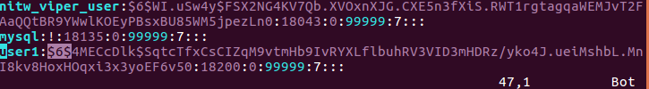
3) Password Files Definition:
A new user is added with the given commands and the shadow file is opened.
Highlighted in the below image is the salt of the password.

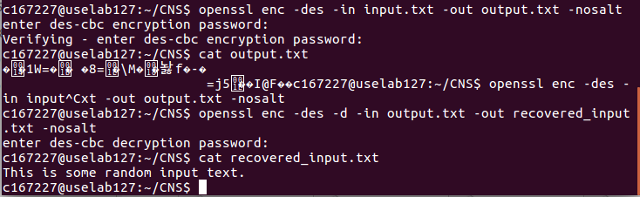
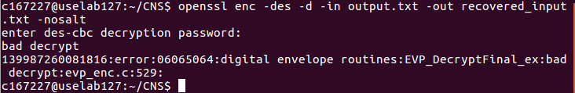
4)
- Encrypt an arbitrary file and decrypt using the good password (with DES and no salt)
A)
- Encrypt an arbitrary file and tryto decrypt it using a wrong password:
A)
- Compare the size of a plaintext and the corresponding cipher. Explain the difference.
The cipher text output would be the nearest multiple of 8 bytes, because DES is used in CBC mode.
The observed input is of 33 bytes, and the resultant output is of 40 bytes length. The additional bytes are padded to the input.

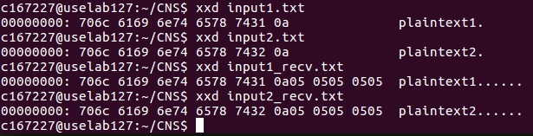
- Comparing plaintexts and nopad plaintexts
A) We see that the outputs of the plaintexts and their nopad equivalents where the padding is not decrypted.

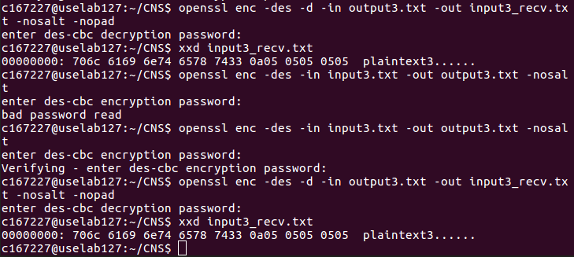
- Without comparing the plaintext3 and plaintext3nopad, can you tell whether the password was strong or not?
A) No. Without comparing both, it is difficult to determine that the password was good or bad.

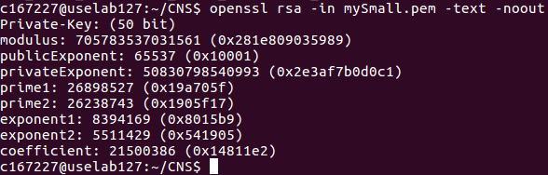
5) Encryption with RSA Key generation syntax:

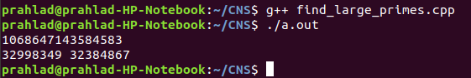
- Crack your own RSA key by factorizing the modulus:
Why could you crack it?
Because the key size was comparetively low i.e. 50 bits in size.
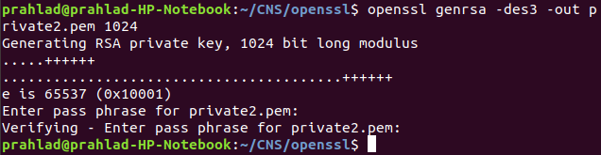
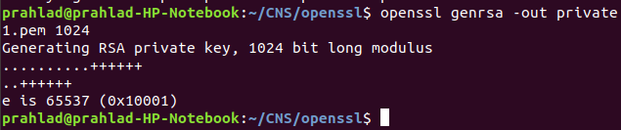
- Create a private key private1.pem of 1024 bits without encryption and private2.pem with encryption.
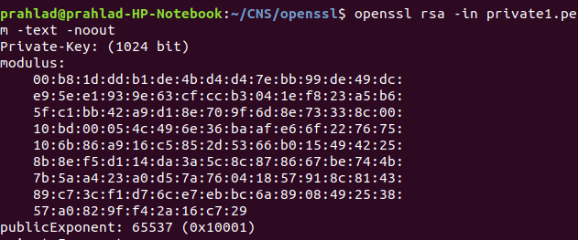
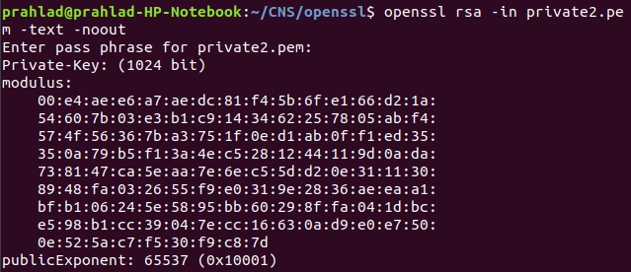
- Retrieve the information from keys private1.pem and private2.pem

- Create a public key associated to the private keys private1.pem and private2.pem.
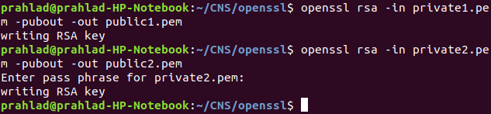
- Should we store the public key in plaintext?
We can store the public keys in plaintext because eventhough they are made public, an attacker must know the factors of the very large modulus we generated i.e the private key.

- Retrieve the information of the two public keys.
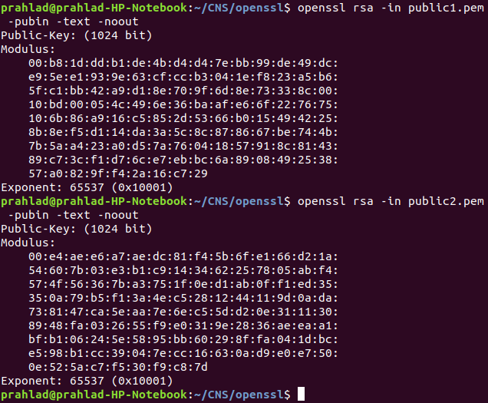
Encryption and Decryption:

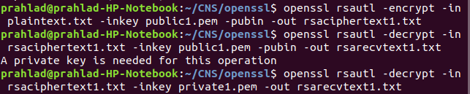
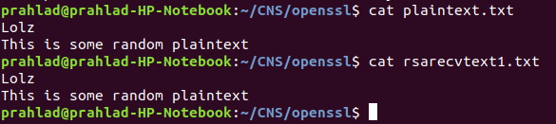
- Encrypt and decrypt a small file.
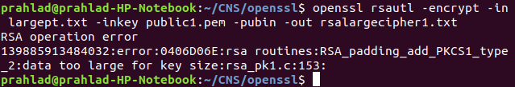
- Encrypt a large file. What happens? Why?
This happens because rsa algorithm works by taking input plaintext and performing modular exponentiation. As this is very slow, RSA can be performed only by splitting very large plaintexts into blocks, but at a time there is a limit to the input plaintext of RSA. This limit depends on the key.
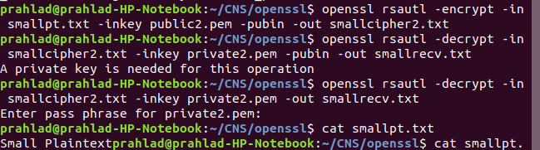
- Encrypt a short message with your partner’s public key, send the cipher to them, as them to decrypt it.
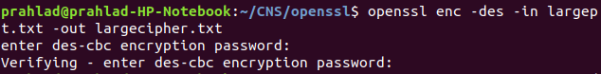
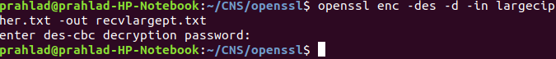
- Encrypt the long message with a symmetric encryption algo by using an arbitrary password. Encrypt the password with the public key of your partner. Your partner must decrypt it and get the message.
Signatures
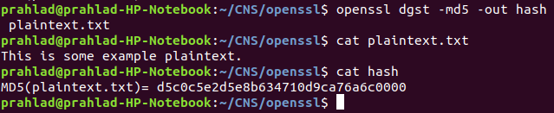
- Sign a message.
Should we use the private key or the public key for the signature?
To sign a message, we use the private key on the author/owner’s side. We use a public key to verify the signature.
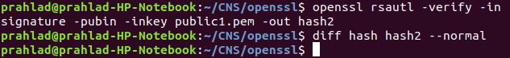
- Verify the signature, use the tool diff.
We find that as there is no difference, both the files are same and thus we have verified the signature.
Certificate generation:
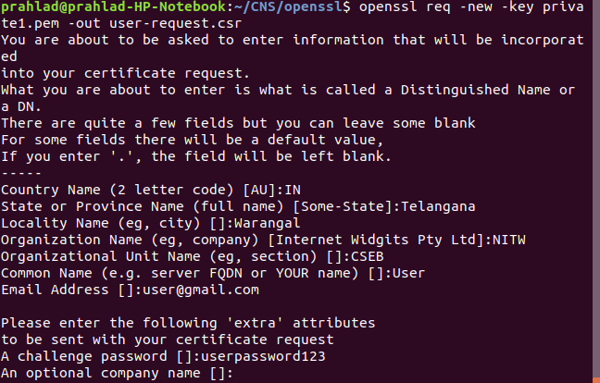
- Create a certificate request called user-request.pem concerning an entity called user. This request is waiting to be signed by a certification authority.

- Visualize the content of the certificate request.
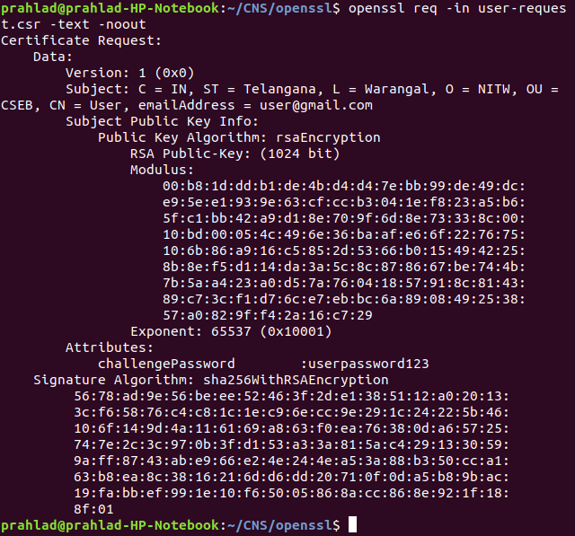

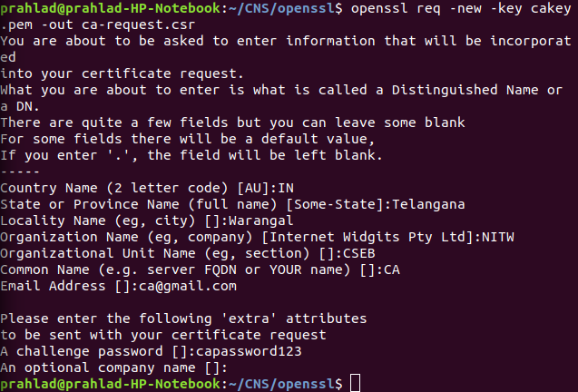
- Create a pair of keys for the certification authority. Create a certificate request called carequest.pem and concerning the certificate authority CA.

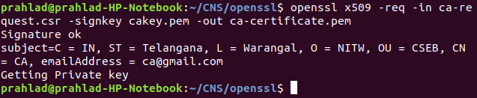
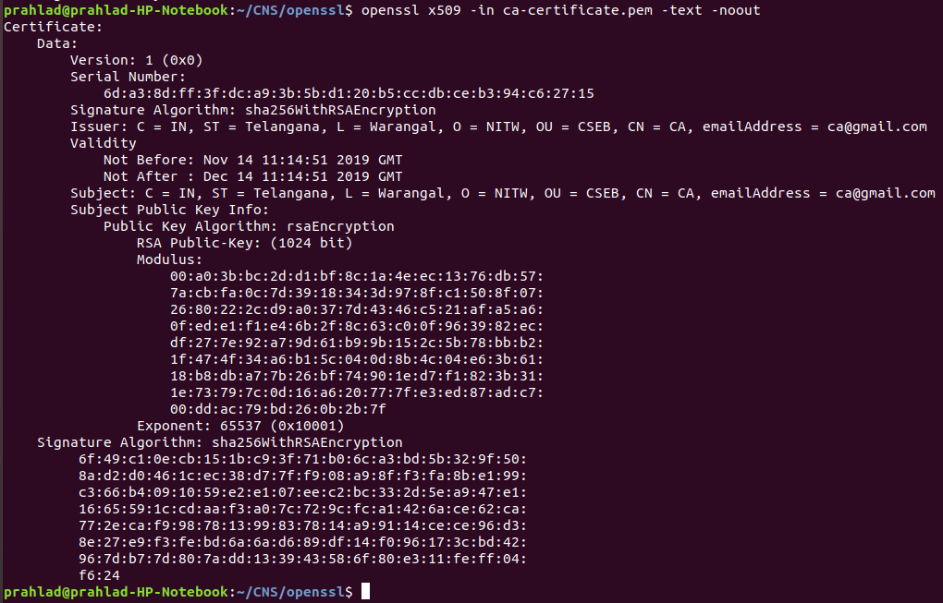
- Autosign the certificate request of CA in certificate called ca-certificate.pem
- Visualize the certificate ca-certificate.pem
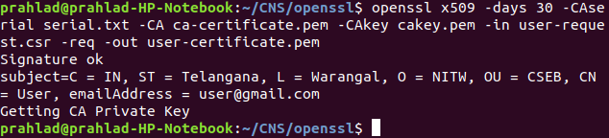
- Sign the certificate request user-request.pem to produce a certificate user-certificate.pem
- Verify the certificate user-certificate.pem
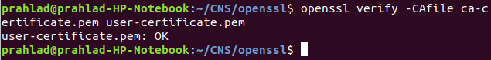

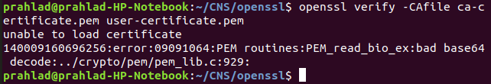
- Modify the content of the certificate user-certificate.pem and try to verify it

Certification Chain:

- Create two certification authorities CA1 and CA2. CA1 is the root certification authority, and CA2 is certified by CA1.
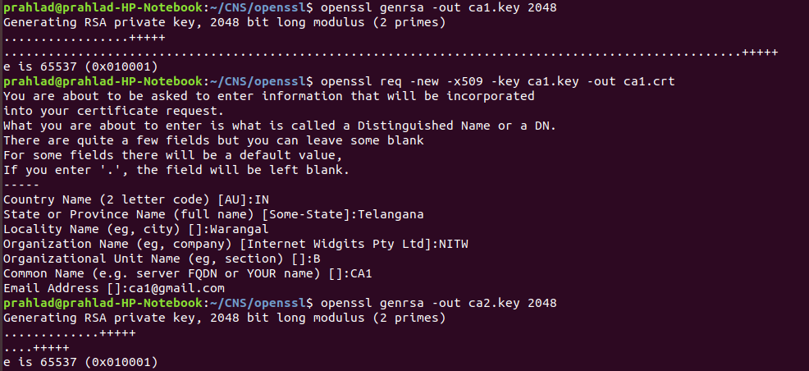
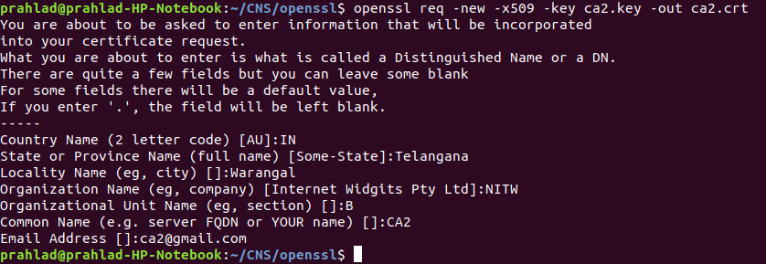
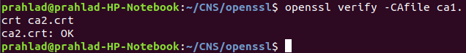

- Create a certificate request and sign it by CA2.
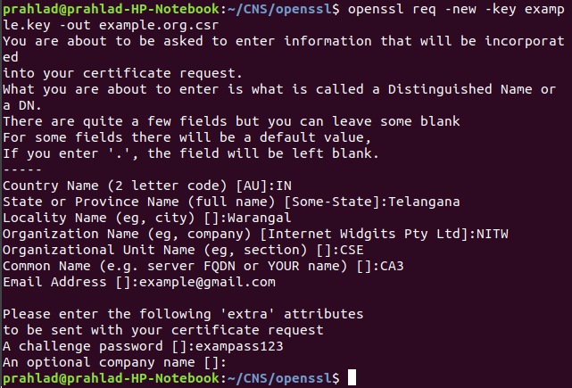
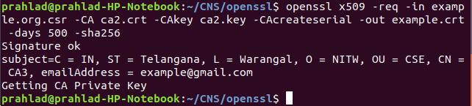

- Verify the complete certification chain
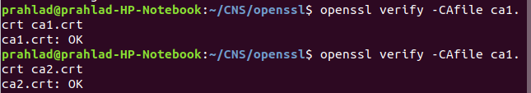

Final Assignment on Openssl
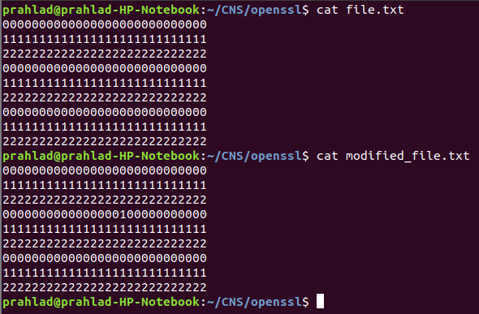
Use AES encryption and mode of operation ECB and CBC to analyze the ciphertext.
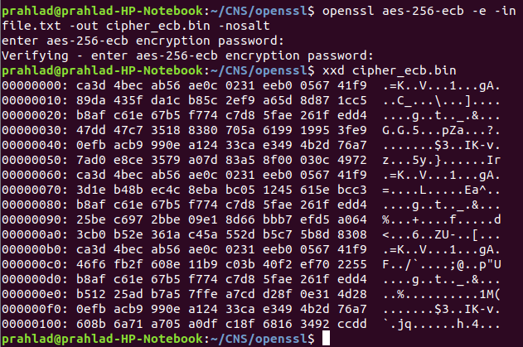
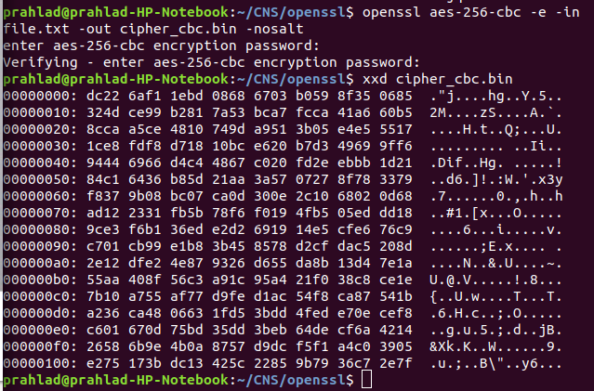
We observe that with ecb there patterns in the resulting ciphertext, whereas in cbc there are no decipherable patterns in the ciphertext.
Next, we generate similar output files for the modified file.
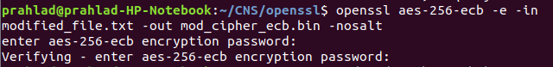
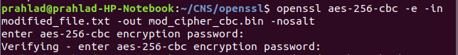
Then, we compare them and note the results.

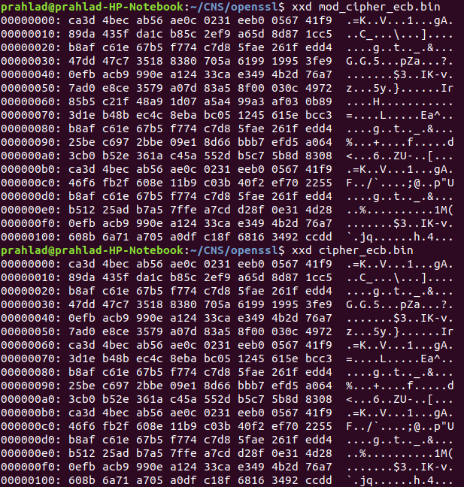
ECB:

Here, the differences between the two files doesnot change very much throughout the entire file.

CBC:
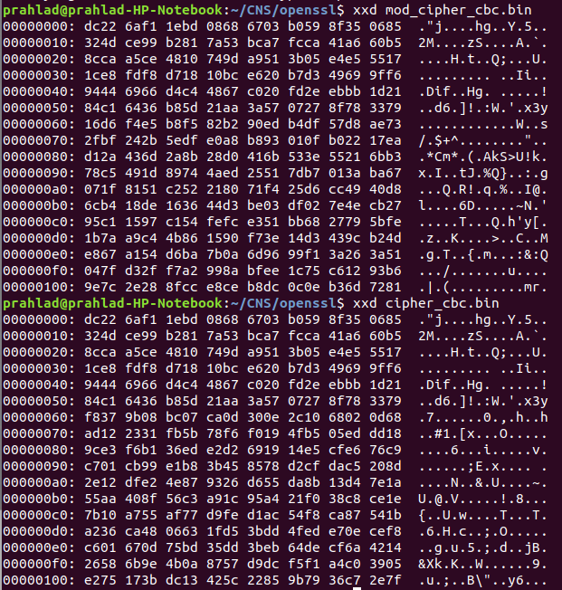
Whereas here, as we look further into the file the differences are pronounced because of the way CBC chains and links the outputs, leading to drastic changes at the end of both the files.

